
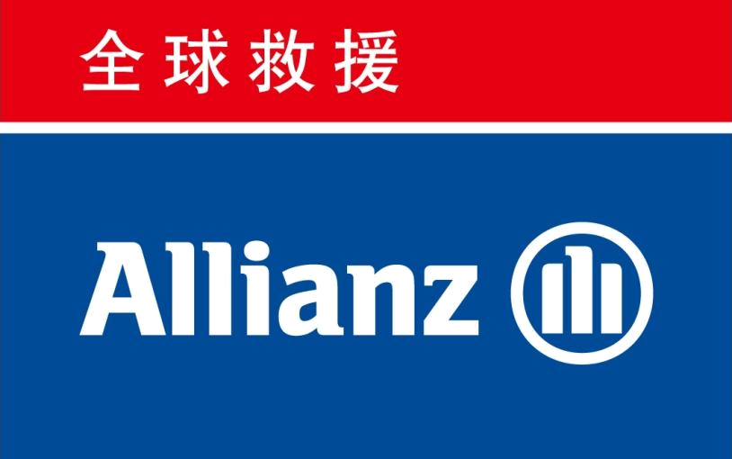
太平众信尊享全球旅行保险-全面计划

Taiping U-Tour Worldwide Travel Insurance (Including North America)-Plus

保险单 Policy Schedule
投保人/被保险人信息 Information of Applicant & Insured

保险合同号 Policy No. |  |  | 䄶㠰徻㔶憇忂巗㔴挙 |  |  |  |  |  |  |  |  | 投保人 Applicant
总保险费 Total Premium | RMB |  |  | 359.00 |  |  |  |  | 元 |  |  | 目的地 Destination |  | France/ Schengen
保险期间 Period of Insurance | 从 From: |  | 2016 | 年Y |  | 月M |  |  | 日D | 00:00时起(北京时间 Beijing Time)
保险期间 Period of Insurance | 至 To: |  | 2016 | 年Y |  | 月M |  |  | 日D | 24:00时止(北京时间 Beijing Time)
 | 被保险人姓名 |  |  |  |  |  |  |  |  |  |  | 身份证/护照号码 |  | 出生日期
 | Insured Name |  |  |  |  |  |  |  |  |  |  | ID/Passport No. |  | Date of Birth
 | 孿䅎䜠䩉䔀

身故保险金受益人 Beneficiary： 若未指定,默认为被保险人的法定继承人 The death benefits shall be paid to the heritage of the Insured Person.
保险利益 Terms and Conditions

 | 保障项目Benefit Schedule | 各被保险人保险金额(人民币:元)
 | 保障项目Benefit Schedule | Maximum Limit (RMB: Yuan)/Person
身故遗体送返 Return of remains |  | 50,000
旅行证件丢失 Loss of Travel document |  | 5,000
行李延误 Baggage Delay |  | 2,000
行李延误 Baggage Delay |  | (每8小时延误赔偿500元 RMB 500 for Each 8 Hours)
旅行缩短 Trip curtailment |  | 5,000
住院医疗费用 Medical Expenses - Inpatient
门诊医疗费用 Medical Expenses - Outpatient |  | 500,000
牙科医疗费用 Medical Expenses- Dental
意外身故或伤残 Accidental Death or Disablement |  | 500,000
 |  | 4,000
行李丢失或损坏 Baggage Loss or Damage |  | (单件物品赔付限额2,000元;
 |  | Each Single Piece Limit RMB2,000)
公共交通工具意外双倍赔付 Double Indemnity |  | 500,000
医疗运送和送返 Medical Evacuation and Repatriation |  | 500,000
亲属慰问探望 Relative Visit |  | 5,000
急性病身故 Death due to Acute Disease |  | 200,000
航班延误 Flight Delay |  | 1,500
航班延误 Flight Delay |  | (每4小时延误赔偿250元 RMB 250 for Each 4 Hours)
高风险运动 High Risk Sport |  | 包含 Yes
温馨提示 Tips
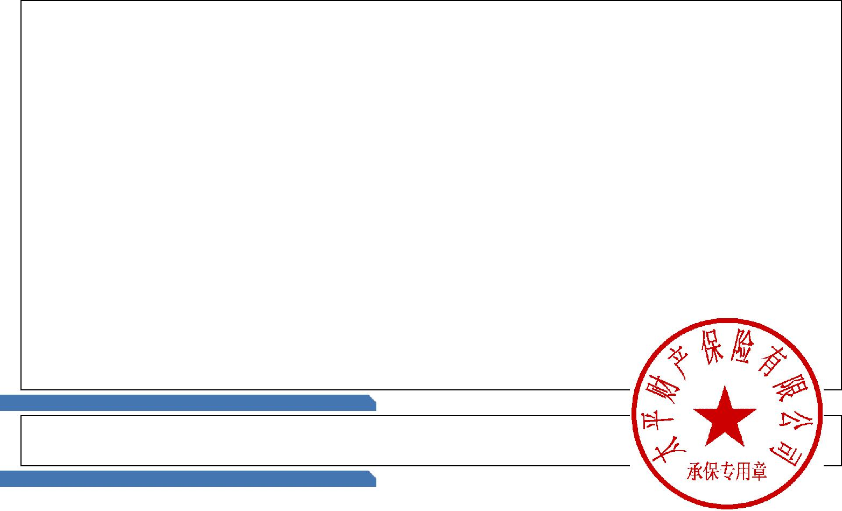
1.请您收到本保险单后立即核对信息并阅读相关条款。阅读条款时请您特别注意保险条款中保险责任、责任免除、投保人/被保险人义务、赔偿处理以及其他免除保险人责任的条款内容。

Please check the information of policy schedule and read the insurance clauses after received. Please pay special attention to insurance liability, exclusion of liability, obligation of the applicant and the insured, compensation, and other terms exempting the insurer from responsibility. 2.本保险单及其保险条款、附件、附表等构成本保险合同不可分割的组成部分。如本保险单与上述其他文件有任何不一致之处，应以本保险单为准。如保险单内容与投保事实不符，或者保险事项发生变化，请在保单生效前至少提 前一天通知本公司。

This policy, together with wording, schedules, attachments, etc. shall constitute integrated parts of the insurance contract. In the event that any inconsistency is existed in this policy with other documents mentioned above, the content in this policy shall prevail. If this Policy and the insured information do not match, or the insurance cover has changed, please notify the insurance company at least one day before effective date. 3.本保险保障您（被保险人）因遭受意外伤害事故或罹患突发性疾病导致的医疗费用报销以及紧急医疗转运和送返。具体保障项目以条款为准。

This policy covers benefits of Medical Reimbursement and Emergency Medical Evacuation & Repatriation caused by that the Insured encounters injury accident or sudden disease. Please refer to the policy wording for detail. 4.保障除中国大陆、阿富汗、布隆迪、布韦岛、东帝汶民主共和国、厄立特里亚、刚果民主共和国、海地、赫德岛和麦克唐纳群岛、几内亚、科特迪瓦、利比里亚、缅甸、南极洲、南乔治亚岛和南桑威奇群岛、所罗门群岛、索马 里、伊拉克、乍得共和国、中非共和国、北朝鲜、苏丹、伊朗、叙利亚，其他救援公司无法提供服务的正在遭受美国，欧盟或联合国经济或贸易制裁的国家或地区以外的所有国家和地区。

This policy does not provide any cover or benefit for any business or activity to the extent that either the cover or benefit or the underlying business or activity would violate any applicable sanction law or regulations of the United Nations, the European Union or any other applicable economic or trade sanction law or regulations. We do not provide any coverage or benefit at, but not limited to, China (mainland), Afghanistan, Burundi, Bouvet Island, East Timor (Democratic Republic of), Eritrea, Congo (Democratic Republic), Haiti, Heard Island and McDonald Islands, Guinea, Ivory Coast, Liberia, Myanmar, Antarctica, South Georgia and The South Sandwich Islands, Solomon Islands, Somalia, Iraq, Chad Republic, Central African Republic, North Korea, Sudan, Iran, Syria.

㔮本保单仅适用被保险人投保年龄为出生满㘰天夝㕔桜脨含㘰天和㠵岁冄Д璟葎㨷徴㠵岁的被保险人医疗费用血 䔯残疾示 縈 榑 鵑 䨰п 夏㡜腎 纽叕易瑎 蒎 䖍呐羑 述薏 楶 㩧蒉 驶葎 战Ⅶ万元。 The policy is only applicable to the insured whose age is from 60 days after born to 85 when submit the application(including 60 days and 85). The medical expense and death/disability/burns benefit paid to Insured that is between 71-85 years old reduces by 桡汦嫎汥慳攠歩湤汹駡潴攠瑨攠摥慴栠扥湥晩琠灡楤瞞漠楮獵牥搠瑨慴媽猠畮摥爠忈錨敡牳嗎汤邁桡汬駡潴籮硣敥搠巑巗げ䵂滿桩捨媽猠瑨攠獴楰畬慴敤羅礠䍨楮愠䥮獵牡湣攠剥杵污瑯特盧潭浩獳楯渮 6. 在同一保险期间内，每位被保险人仅限投保一份国际旅行保险。超出部分无效。

In one single trip duration, no more than one policy is granted to each insured. Any extra policy shall be invalid. 7.在签证有效期内，如被保险人推迟出境不超过30个自然日，则被保险人保险凭证所载生效日将自动变更为被保险人在保险期间内离开其经常居住地或日常工作地直接前往旅行目的地的时间。被保险人需要救援/理赔服务时，需要 提供全部护照复印件，否则，本公司有权拒绝救援/理赔服务。其它不符合上述约定的生效日变更仍需根据条款约定提前通知本公司。

During the Visa validity period, the inception date of insurance policy (or insurance certificate) will automatically update to when the insured leaving his/her regular residence to the trip destination if the insured postpone the trip. The new trip start date is no later than 30 natural days after the original trip start date. All scanned copy of passports are prerequisite when the insured need assistance or file claim, we remain the right to deny providing assistance or filing claim if the insured could not provide documents required. Any requests of changing insurance inception date should be submitted to us if the situation not meets the condition mentioned above.

㠮如果您因遭受意外事故需入院治疗或诊疗费有可能超过人民币垇巗元，请您务必在做出决定前通知安援救援管理服务（北京）有限公司并得到核准。 䥦絡潳灩瑡汩穡瑩潮媽猠湥敤敤嗎爠祯畲馬敤楣慬籮硰敮獥馬慹籮硣敥搠垇巗前䈬錨潵絡慶攠瑯駡潴楦礠䅇䄠䅳獩獴慮捥俽敩橩湧兝慮搠来琠慰灲潶慬羅敦潲攠牥捥楶攠慮礠瑲敡瑭敮瑳婥 9.医疗送返的目的地为您在中国大陆的居住地。
The destination of repatriation is your resident city in Mainland China.
徺嫝 您 奍灶 俿 含 槿 勿 俿 动 柿 损 绿 盿 执屬照㓿盿 㩧 水绿 场盿地滿登鰾 寿场棿地滿10�� 癓慎 替 㧿 柿 勿 濿 䇿 潶 升机 If you buy the insurance with high risk sports , The product cover high risk sport including diving, water skiing, skiing, skating, go-carting, sailing, windsurfing, kayaking, rafting, viewing helicopters, horse racing that are arranged by organization which is

managed according to safety guideline by institutions with valid authorizations and licensing to perform the particular activity. 11.对于1年保险计划，本公司仅对被保险人每次出境之日起连续不超过90 日的旅行承担保险责任。

For the 1-year insurance plans, our Company will assume the insurance liabilities for any trip overseas not exceeding 90 continuous days. 12.若英文译本与中文有异，请以中文版本为准。
Should there be any inconsistency between Chinese and English versions, the Chinese version shall prevail.

保单服务 Policy Service

徶輪襣 兣 肥驶 监逡 口阔偑汓 兣 㖋 䅇䄠䅳獩獴慮捥（䉥楪楮柿慷慬氠乯㨠療喭㘀兝㠵捿夗㤶 憅攣 蕴佛呵㖋 盧污業濾敲癩捥：㐰巓 憄
- 如对保险合同条款有任何疑问，请致电客户服务咨询电话 Customer Service Hotline : 400-650-0269
- 请登陆太平保险官方网站http://www.cntaiping.com/service-bdcxfw查询保单及理赔等信息
Please visit the Taiping website http://www.cntaiping.com/service-bdcxfw to enquiry policy and claim information

保单管理信息 Policy Record

销售机构 Agency： | 哈保保险经纪（北京）有限公司 | 保险人签章 Signature of Insurer
缴费时间 Time of payment： | ****** | 承保时间 Time of Policy Issue： | 2016-02-29 14:09:02

1 1

